

**ASSIGNMENT 10**

[Design a **4-BIT REGISTER** with (i) parallel-in/parallel-out (ii) serial-in/serial-out features using 2 input NAND GATES]



**NAME: ROHIT SADHU**

**ROLL NO.: 002010501074**



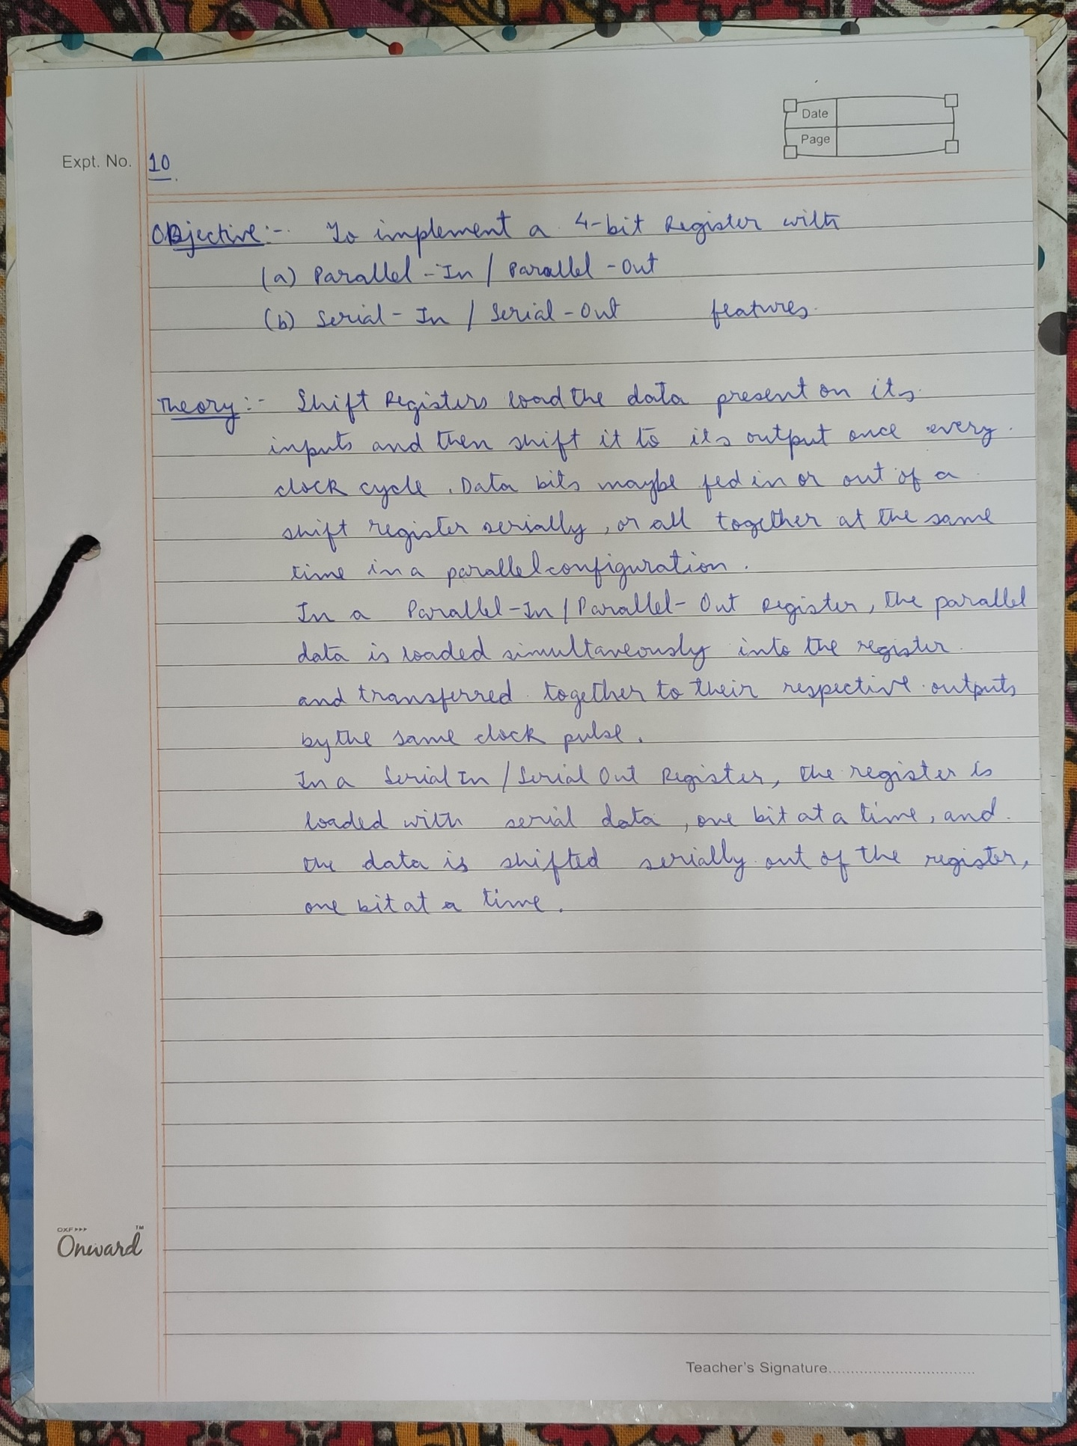

**CIRCUIT DIAGRAM:**

